Build a matrix by pressing buttons of an interface in Tkinter which extract data from columns of an excel file.

Good evening I would like to ask for help.

From the matrix in excel shown below

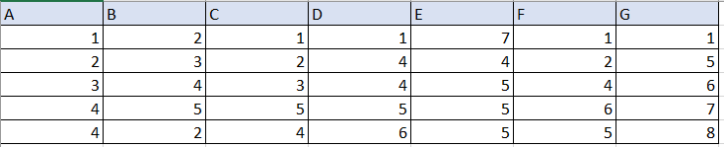

I want to extract the numeric values from columns A, C and E to form a matrix like the one shown below.

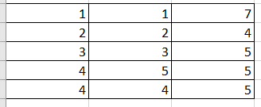

However, I want to do it, through this interface that I have developed in Tkinter by pressing the buttons A, C and E.

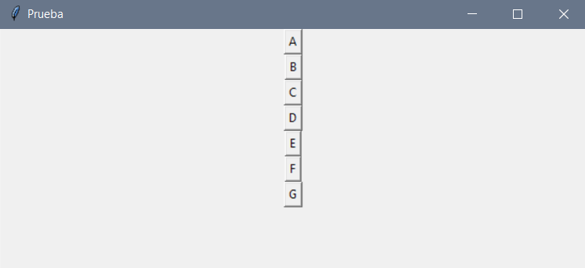

Currently I have programmed in such a way that when pressing the buttons, the columns are extracted from the file in excel, as shown below.

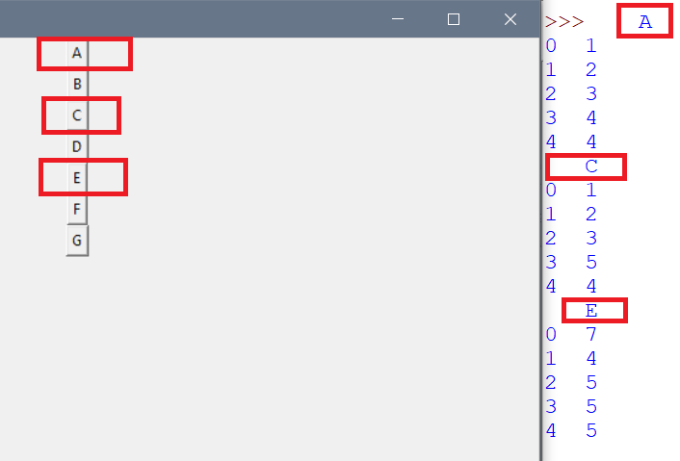

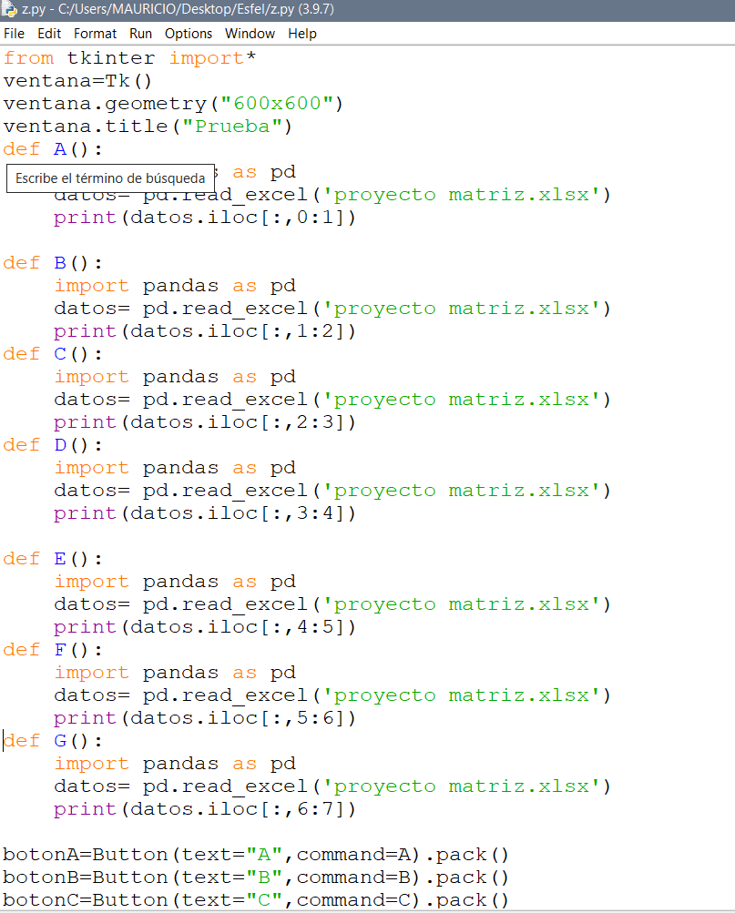

However, I want to form a matrix with only the numerical values, how can I do it?

note: I would like to design in such a way as to build the matrix grouping any column of the excel file for example A, B and C or D, F and G

Previously I have managed to form the matrix by extracting the numerical values from columns A, C and E using the following code

